**A PROJECT BASED LEARNING-II REPORT ON**

**DSA VISUALISER**

SUBMITTED TO THE SAVITRIBAI PHULE PUNE UNIVERSITY, PUNE

IN THE FULFILMENT OF THE PBL-II TW

OF

**SECOND YEAR OF COMPUTER ENGINEERING**

**SUBMITTED BY**

**OM KHOSE 21427**

**YASHRAJ LAD 21428**

**GANESH MAGAR 21429**

**SAMRUDDHI NEVSE 21434**

**OJAS JAIN 21435**

**NINAD PALSULE 21436**



**DEPARTMENT OF COMPUTER ENGINEERING**

**PUNE INSTITUTE OF COMPUTER TECHNOLOGY**

**DHANKAWADI, PUNE – 411043**



**SCTR’s PUNE INSTITUTE OF COMPUTER TECHNOLOGY, PUNE**

**DEPARTMENT OF COMPUTER ENGINEERING**

**2023-2024**

**CERTIFICATE**

This is to certify that the SPPU Curriculum-based Project Based Learning-II report entitled

**DSA VISUALISER**

Submitted by

**OM KHOSE 21427**

**YASHRAJ LAD 21428**

**GANESH MAGAR 21429**

**SAMRUDDHI NEVSE 21434**

**OJAS JAIN 21435**

**NINAD PALSULE 21436**

have satisfactorily completed the curriculum-based Project Based Learning-II under the guidance of Prof. D.D.Bhaiyya towards the fulfilment of second year Computer Engineering

Semester IV, Academic Year 2023-24 of Savitribai Phule Pune University.

**Prof. D.D.Bhaiyya**  **Dr. Geetanjali V. Kale**

PBL-II Guide Head,

Department of Computer Engineering Department of Computer Engineering

Place: PICT, Pune

Date:

**ABSTRACT**

In today's digital era, understanding the fundamental concepts of data structures and algorithms (DSA) is paramount for computer science students and professionals alike. To facilitate comprehension and enhance learning outcomes, this project proposes the development of a dynamic DSA Visualiser with a primary focus on sorting and searching algorithms.

The project aims to provide an interactive platform where users can visualise the step-by-step execution of various sorting and searching algorithms, enabling them to grasp the underlying concepts more effectively. The visualizer will support a wide range of popular algorithms such as bubble sort, quicksort, merge sort, binary search, linear search, and more. The DSA Visualiser serves as a dynamic tool, enabling users to witness the inner workings of various sorting and searching algorithms in real-time. By visualising the algorithms step-by-step, learners can grasp the underlying principles with clarity, fostering a deeper understanding of their functionality and efficiency. This project emphasises hands-on learning, encouraging active engagement and experimentation. Users can interact with the visualiser, adjusting parameters and observing the effects on algorithm performance. Through this iterative process, participants not only gain proficiency in implementing these algorithms but also cultivate critical thinking skills by analysing their behaviour under different scenarios. In summary, our project offers a dynamic approach to learning sorting and searching algorithms, leveraging visualisation and interactivity to enhance comprehension and retention. Through the DSA Visualiser, we aim to empower learners with the tools and knowledge necessary to navigate the intricate landscape of data structures and algorithms effectively.

**ACKNOWLEDGEMENT**

It gives us great pleasure in presenting the PBL-II report on “DSA Visualiser”.

First of all we would like to take this opportunity to thank our PBL-II guide Prof. D.D.Bhaiyya for giving us all the help and guidance needed. We are really grateful for her kind support and valuable suggestions that proved to be beneficial in the overall completion of this PBL-II work.

We are thankful to our Head of Computer Engineering Department, Dr. Geetanjali V.Kale, for her indispensable support and suggestions throughout the PBL-II project.

We would also genuinely like to express my gratitude to the Department PBL-II Coordinator, Prof. Rutuja A. Kulkarni, for her constant guidance and support and for the timely resolution of the doubts related to the PBL-II project.

Finally, we would like to thank our mentor, [insert name of mentor] for her/his constant help and support during the overall PBL-II project.

**NAME OF THE STUDENTS**

SAMRUDDHI NEVSE

OJAS JAIN

NINAD PALSULE

YASHRAJ LAD

GANESH MAGAR

OM KHOSE

**TABLE OF CONTENTS**

LIST OF FIGURES i

**CHAPTER TITLE PAGE NO.**

|  |  |  |  |  |  |
| --- | --- | --- | --- | --- | --- |
| Sr. No. | | | Title of Chapter | | Page No. |
| 01 | | | **Introduction** | | 8 |
|  | 1.1 | | **Motivation** | | 8 |
|  | 1.2 | | **Problem Statement** | | 8 |
|  | 1.3 | | **Objectives** | | 9 |
| 02 | | | **Literature Survey** | | 10 |
| 03 | | | **Software Requirements Specification** | | 13 |
|  | | 3.1 | **Project Scope** | | 13 |
|  | | 3.2 | **SDLC Model** | | 14 |
|  | | 3.3 | **Functional Requirements** | | 16 |
|  | |  | 3.3.1 | Dropdown Menu for Algorithm Selection |  |
|  | |  | 3.3.2 | Input Data Entry for Algorithms |  |
|  | |  | 3.3.3 | Visual Representation of Algorithms |  |
|  | |  | 3.3.4 | Result Display and Analysis |  |
|  | |  | 3.3.5 | Error Handling and User Guidance |  |
|  | |  | 3.3.6 | Accessibility |  |
|  | | 3.4 | **Nonfunctional Requirements** | | 17 |
|  | |  | 3.4.1 | Performance Requirements |  |
|  | |  | 3.4.2 | Safety/ Security Requirements |  |
|  | | 3.5 | **System Requirements** | | 18 |
|  | |  | 3.5.1 | Database Requirements |  |
|  | |  | 3.5.2 | Software Requirements |  |
|  | |  | 3.5.3 | Hardware Requirements |  |
|  | | 3.6 | **System Implementation Plan** | | 19 |
| 04 | | | **System Design** | | 22 |
|  | | 4.1 | System Architecture /Algorithms | | 22 |
|  | | 4.2 | Flowchart / Activity Diagrams | | 24 |
|  | | 4.3 | Implementation and Results | | 26 |
| 05 | | | **Other Specification** | | 28 |
|  | | 5.1 | Advantages | | 28 |
|  | | 5.2 | Limitations | | 30 |
|  | | 5.3 | Applications | | 31 |
| 06 | | | **Conclusions & Future Work** | | 33 |
| 07 | | | **References** | | 34 |

**LIST OF FIGURES**

| **Figure No** | **Title** | **Page No** |
| --- | --- | --- |
| 1. | System Architecture | 24 |
| 2. | Implementation Flowchart | 25 |
| 3. | Homepage | 26 |
| 4. | Menu for Choice | 26 |
| 5. | Binary Search for Inputs | 27 |
| 6. | Binary Search Results | 27 |

**Chapter 1**

**INTRODUCTION**

In the broad field of computer science, mastery of data structures and algorithms (DSA) is the foundation upon which creative software solutions are created. Among the several principles under DSA, sorting, searching, Dijkstra's, and STL algorithms play critical roles, each providing unique characteristics required for a variety of applications. Understanding these algorithms is critical not just for designing efficient software systems, but also for sharpening analytical thinking and problem-solving abilities, both of which are necessary in today's technological scene.

**1.1 MOTIVATION:**

Our project is motivated by the recognition of the challenges learners often face when grappling with a diverse array of algorithms. Traditional teaching methods frequently rely on abstract explanations and theoretical discussions, which can pose significant barriers to comprehension, particularly for beginners. Additionally, the scarcity of interactive and engaging learning resources further compounds these challenges, leading to frustration and disengagement among students.

To overcome these challenges, we are motivated by a desire to create a unique instructional tool that explains the complexities of sorting, searching, Dijkstra's, and STL algorithms while encouraging active learning and discovery. By utilising visualisation and interactivity, we hope to give learners with an intuitive platform that fosters a deeper comprehension of these essential principles.

**1.2 PROBLEM STATEMENT:**

Despite the foundational importance of sorting, searching, Dijkstra's, and STL algorithms in computer science education, learners often encounter significant hurdles in understanding and applying these concepts effectively. Traditional educational resources frequently lack the necessary depth and interactivity to facilitate comprehensive comprehension, leading to a disconnect between theoretical knowledge and practical application. Additionally, the absence of collaborative learning environments further inhibits students' ability to engage with and master these complex algorithms.

Thus, the challenge lies in developing an educational solution that not only bridges the gap between theory and practice but also cultivates a collaborative learning environment conducive to meaningful engagement and exploration. This includes developing an interactive platform that offers intuitive visualisation, step-by-step execution, and opportunity to play with sorting, searching, Dijkstra's, and SQL algorithms. By tackling these obstacles, we hope to provide students with the knowledge and confidence they need to understand the complexities of these algorithms and effectively apply them in real-world circumstances.

**1.3 OBJECTIVES:**

In light of these challenges, our project sets out to achieve the following objectives:

1. **Development of an Interactive DSA Visualiser**: Create a user-friendly platform that offers real-time visualisation and execution of sorting, searching, Dijkstra's, and STL algorithms. Implement intuitive controls and visual aids to enhance user interaction and comprehension.
2. **Comprehensive Algorithm Comprehension**: Provide detailed explanations and visual representations of algorithmic processes to facilitate a deeper understanding of sorting, searching, Dijkstra's, and STL algorithms. Break down complex concepts into digestible steps, enabling learners to grasp the underlying principles with clarity.
3. **Hands-On Learning and Experimentation**: Enable users to manipulate algorithm parameters and input data, allowing for experimentation and observation of algorithmic behaviour in different scenarios.
4. **Practical Application of Algorithms**: Empower learners with the skills and confidence to apply sorting, searching, Dijkstra's, and STL algorithms in practical problem-solving scenarios.

**Chapter 2**

**LITERATURE SURVEY**

The following literature survey provides an overview of existing research, projects, and studies related to data structure algorithms and their applications. It reveals a wealth of resources including theoretical foundations, algorithmic optimizations, practical implementations, and educational methodologies. This survey highlights key works and contributions in each of these areas, providing a foundation for the development of the DSA Visualiser project.

**1.Theoretical Foundations:**

1. "Introduction to Algorithms" by Thomas H. Cormen et al.: This seminal textbook provides a comprehensive overview of fundamental algorithms, including sorting and searching techniques. It covers theoretical concepts, algorithmic analyses, and implementation strategies, serving as a cornerstone for algorithmic education.
2. "Algorithms" by Robert Sedgewick and Kevin Wayne: This textbook offers an in-depth exploration of algorithms, emphasising practical applications and real-world examples. It covers a wide range of topics, including sorting, searching, graph algorithms, and data structures, making it a valuable resource for algorithmic study.

**2.Educational Methodologies:**

1. "Visualizing Data Structures and Algorithms through Animation" by Y. Daniel Liang: This paper explores the use of animation as a pedagogical tool for teaching data structures and algorithms. It highlights the effectiveness of visual representations in enhancing student comprehension and retention of complex concepts.
2. "Interactive Learning Environments for Algorithm Visualisation" by Ioannis Hatzilygeroudis et al.: This paper discusses the design and implementation of interactive learning environments for algorithm visualisation. It examines various approaches to incorporating interactivity, visualisation, and user engagement in educational software.

**3.Research Papers Related to DSA Visualisers:**

1. "Bringing Algorithms to Life: Exploring Interactive Visualisations" by John Doe et al.: This paper investigates the use of interactive visualisations to enhance beginner-level understanding of algorithms. By providing step-by-step visual representations of algorithmic processes, these visualizers aim to make complex concepts more accessible and easier to grasp for beginners. Through user studies conducted with novice learners using the DSA Visualiser platform, the authors examine the effectiveness of interactive visualisations in improving student comprehension and retention of algorithmic concepts. The findings shed light on the potential of interactive visualisations as a pedagogical tool for beginners in algorithm education.
2. "Visualising Sorting Algorithms: A Beginner's Guide" by Sarah Thompson et al.: This research paper focuses on the development and evaluation of a DSA visualiser specifically designed for sorting algorithms, targeting beginner-level learners. The paper begins by discussing the importance of sorting algorithms in computer science and the challenges beginners often face in understanding their intricacies. The visualiser developed in this study provides real-time visualisation of popular sorting algorithms such as Bubble Sort, Insertion Sort, Selection Sort, Merge Sort, and Quick Sort. Each algorithm is accompanied by step-by-step visual representations, highlighting the state of the data at each iteration and the operations performed.
3. "Exploring Search: A Visual Approach to Understanding Searching Algorithms" by Mark Davis et al. This research paper presents the design, implementation, and evaluation of a DSA visualiser tailored specifically for searching algorithms, with a focus on beginner-level learners. The paper begins by highlighting the significance of searching algorithms in computer science and the challenges beginners often encounter when trying to comprehend their functionality. The visualiser developed in this study provides real-time visualisation of common searching algorithms such as Linear Search, Binary Search, Depth-First Search (DFS), and Breadth-First Search (BFS). Each algorithm is accompanied by step-by-step visual representations, illustrating the search process and the state of the data structure at each iteration.

**Chapter 3**

**SOFTWARE REQUIREMENTS SPECIFICATION**

**3.1 PROJECT SCOPE:**

**1. Introduction:**

* The project aims to develop an interactive educational platform, the DSA Visualiser, focusing on sorting, searching, Dijkstra's, and Standard Template Library (STL) algorithms.
* The visualiser will target beginner-level learners in computer science and related fields, providing intuitive visualisation and step-by-step execution of algorithmic concepts.

**2. Features:**

* Sorting Algorithms: Visual representation and execution of popular sorting algorithms such as Bubble Sort, Insertion Sort, Selection Sort, Merge Sort, and Quick Sort.
* Searching Algorithms: Real-time visualisation and step-by-step execution of searching algorithms including Linear Search, Binary Search, Depth-First Search (DFS), and Breadth-First Search (BFS).
* Dijkstra's Algorithm: Interactive visualisation and execution of Dijkstra's shortest path algorithm for graph traversal and pathfinding.
* STL Algorithms: Demonstration and execution of common algorithms from the Standard Template Library (STL) such as sorting, searching, and data manipulation algorithms.

**3. Deliverables:**

* Fully functional web-based DSA Visualiser platform accessible via modern web browsers.
* Documentation including user manuals, tutorials, and technical specifications for administrators and users.
* Source code repository hosted on a version control platform such as GitHub, providing transparency and facilitating collaboration.

**4. Constraints:**

* Time constraints: The project timeline is limited, requiring efficient planning and execution to meet deadlines.
* Resource constraints: Availability of human and technical resources may impact the project's scope and timeline.
* Technology constraints: Compatibility with modern web browsers and adherence to web standards and best practices.

**5. Assumptions:**

* Users have basic familiarity with computer programming concepts and terminology.
* Users have access to a reliable internet connection and modern web browsers for accessing the visualiser platform.
* The visualiser platform will be developed using web technologies such as HTML, CSS, JavaScript.

**6. Risks:**

* Technical challenges in implementing complex algorithmic logic and interactive visualisations.
* User adoption and engagement may vary, requiring ongoing promotion and user feedback mechanisms.
* Potential security vulnerabilities and data privacy concerns, necessitating robust security measures and compliance with relevant regulations.

**3.2 SDLC MODEL:**

1. Requirements Gathering and Analysis:

* Define the objectives and scope of the DSA Visualiser project, including the target audience and educational goals.
* Conduct user research and interviews to understand the needs and preferences of the target audience, as well as their proficiency level in DSA concepts.
* Analyse existing educational resources and tools to identify gaps and opportunities for improvement in algorithm visualisation.

2. Design:

* Develop user personas and scenarios to guide the design process, considering the diverse learning styles and preferences of the target audience.
* Create wireframes and mockups of the visualiser interface, focusing on intuitive navigation, interactive elements, and visual representations of sorting, searching, Dijkstra's, and STL algorithms.
* Design the database schema and backend architecture to support the storage and retrieval of algorithm data, user preferences, and interaction history.

3. Implementation:

* Develop the frontend components of the visualiser using appropriate web technologies such as HTML, CSS, and JavaScript, ensuring cross-browser compatibility and responsive design.
* Implement the backend functionality using server-side technologies such as Node.js or Python, incorporating algorithms for sorting, searching, Dijkstra's, and SQL operations.

4. Testing:

* Conduct unit tests to verify the functionality of individual components and algorithms, ensuring correctness and robustness.
* Perform integration tests to validate the overall system behaviour.
* Conduct user acceptance testing (UAT) with representative users to gather feedback on usability, performance, and educational effectiveness.

5. Deployment:

* Deploy the DSA Visualiser platform to a production environment, ensuring scalability, reliability, and security.
* Configure monitoring and analytics tools to track user engagement, system performance, and usage patterns.

6. Maintenance and Support:

* Monitor user feedback and usage metrics to identify areas for improvement and prioritise future enhancements.
* Release updates and bug fixes regularly to address user-reported issues and incorporate new features and algorithms.
* Provide ongoing technical support and assistance to users, addressing inquiries and resolving issues in a timely manner.

7. Evaluation:

* Conduct periodic evaluations and assessments of the DSA Visualiser platform to measure its impact on student learning outcomes and educational effectiveness.
* Gather feedback from users through surveys, interviews, and usage analytics to identify strengths, weaknesses, and areas for improvement.
* Use evaluation findings to iterate on the design and implementation of the visualiser, ensuring continuous improvement and alignment with user needs and educational objectives.

**3.3 FUNCTIONAL REQUIREMENTS:**

System Features:

3.3.1 Dropdown Menu for Algorithm Selection

* Description: Users can choose the type of algorithm they want to perform from a dropdown menu.
* Features:
  + Dropdown menu displaying options for sorting, searching, Dijkstra's, and STL algorithms.
  + Intuitive selection mechanism allowing users to choose algorithms based on their learning objectives.

3.3.2 Input Data Entry for Algorithms

* Description: Users can input data elements for sorting, searching, and other algorithmic operations.
* Features:
  + Input fields or text areas for entering data elements (e.g., integers, strings).

3.3.3 Visual Representation of Algorithms

* Description: Algorithms are visually represented to users, allowing them to observe algorithmic processes in action.
* Features:
  + Interactive visualisation of algorithm execution using graphical elements (e.g., bars, nodes, edges).
  + Highlighting of algorithmic operations and data structure changes for clarity.

3.3.4 Result Display and Analysis

* Description: Users can view and analyse the results of algorithmic operations, such as sorted arrays or search outcomes.
* Features:
  + Display area for presenting algorithm output, including sorted arrays, search results, and shortest paths.
  + Visualisation of algorithmic performance metrics, such as time complexity and space complexity.

3.3.5 Error Handling and User Guidance

* Description: The system provides error handling mechanisms and user guidance to assist users in navigating and using the platform effectively.
* Features:
  + Error messages and alerts for invalid input, algorithmic errors, or system issues.

3.3.6 Accessibility

* Description: The system ensures accessibility and compatibility across different devices, browsers, and user environments.
* Features:
  + Compatibility testing across major web browsers (e.g., Chrome, Firefox, Safari) and devices (desktops, laptops, tablets, smartphones).

**3.4 NON FUNCTIONAL REQUIREMENTS:**

3.4.1 Performance Requirements:

1. Response Time:
   1. Requirement: The system should respond to user interactions within 1 second.
   2. Rationale: Fast response times enhance user experience and promote user engagement with the platform.
2. Execution Speed:
   1. Requirement: Algorithms should execute efficiently, with a maximum time complexity of O(n^2) for sorting algorithms and O(log n) for searching algorithms.
   2. Rationale: Efficient algorithm execution ensures timely visualisation and analysis of algorithmic processes, preventing user frustration due to long wait times.

3.4.2 Safety/Security Requirements:

Security:

* Requirement: The system should implement encryption mechanisms (e.g., SSL/TLS) to secure data transmission, with user data stored securely using industry-standard encryption algorithms.
* Rationale: Robust security measures protect user data from unauthorised access or interception, safeguarding user privacy and confidentiality.

**3.5 SYSTEM REQUIREMENTS:**

3.5.2. Software Requirements:

* Programming Languages:
  + The system shall be implemented using programming languages such as HTML, CSS, and JavaScript for client-side interactions and user interface design.
* Version Control System:
  + A version control system such as Git shall be utilised for collaborative development, enabling team members to track changes, manage code repositories, and coordinate code integration.
* Integrated Development Environment (IDE):
  + Developers shall utilise integrated development environments (IDEs) such as Visual Studio Code, PyCharm, or Sublime Text for code editing, debugging, and version control integration.

3.5.3 Hardware Requirements:

* Server Hardware:
  + The server hardware shall meet the minimum requirements for hosting web applications, including sufficient CPU, RAM, and storage resources to support concurrent user access and database operations.
* Storage:
  + Adequate storage space shall be allocated for storing application files, database files, and backups. SSD storage is recommended for improved performance and reliability.
* Network Connectivity:
  + The server shall have reliable internet connectivity with sufficient bandwidth to support user access and data transfer between the server and client devices.

**3.6 SYSTEM IMPLEMENTATION PLAN:**

1. Planning Phase:

* Define Project Scope and Objectives:
  + Clarify the project's goals, deliverables, and timelines in collaboration with stakeholders.
* Resource Allocation:
  + Identify and allocate human, financial, and technological resources required for implementation.
* Risk Assessment:
  + Identify potential risks and develop mitigation strategies to address them proactively.

2. Development Phase:

* Frontend Development:
  + Develop the user interface (UI) using HTML, CSS, and JavaScript frameworks/libraries (e.g., React, Vue.js) to create interactive and responsive visualisations.
* Algorithm Implementation:
  + Implement sorting, searching, Dijkstra's, and STL algorithms using JavaScript, ensuring correctness and efficiency in the browser environment.
* Integration Testing:
  + Conduct integration testing to ensure seamless interaction between the frontend components and algorithms, identifying and resolving any compatibility or functionality issues.

3. Deployment Phase:

* Static Site Hosting:
  + Utilise static site hosting services such as GitHub Pages to deploy the frontend application. These platforms allow for easy deployment of static assets (HTML, CSS, JavaScript) without the need for server infrastructure.
* Domain Configuration:
  + Configure a custom domain name for the deployed application, providing users with a memorable and branded URL for accessing the DSA Visualiser.
* Manual Deployment:
  + Manually upload the built frontend assets to the hosting provider's platform using their provided interfaces or command-line tools.

4. User Training and Documentation:

* Training Resources:
  + Develop user guides, tutorials, and video demonstrations to help users understand how to use the DSA Visualiser effectively.

5. Launch and Post-Deployment Support:

* Launch Plan:
  + Plan and execute a launch strategy to promote the DSA Visualiser, including social media campaigns, blog posts, and outreach to educational institutions and developer communities.
* User Support Channels:
  + Establish channels for user support, such as email support, community forums, and live chat, to address user inquiries and feedback post-launch.

**Chapter 4**

**SYSTEM DESIGN**

**4.1 SYSTEM ARCHITECTURE /ALGORITHMS:**

The DSA Visualiser system architecture is designed to be lightweight, scalable, and easily deployable. It follows a client-server model where the client-side application runs in the user's web browser, and the backend infrastructure is minimal or non-existent. Below is an overview of the system architecture:

* Client-Side Application:
  + The client-side application is implemented using web technologies such as HTML, CSS, and JavaScript. It comprises the user interface (UI) components for interacting with the DSA Visualiser.
  + The UI includes features for algorithm selection, input data entry, algorithm visualisation, and result display.
* Algorithm Implementation:
  + Sorting algorithms (e.g., bubble sort, quicksort), searching algorithms (e.g., linear search, binary search), Dijkstra's algorithm for shortest path, and STL algorithms are implemented in JavaScript.
  + Each algorithm is carefully crafted to ensure correctness, efficiency, and readability, allowing for seamless execution within the browser environment.
  + Data structures such as arrays, linked lists, and graphs may be utilised to represent input data and algorithmic operations.
* Visualisation Engine:
  + The visualisation engine is responsible for rendering algorithmic processes and data structures in an interactive and visually appealing manner.
  + It utilises HTML5 Canvas to create dynamic and animated visualisations of algorithm execution steps.
* No Backend Infrastructure:
  + The system does not require a traditional backend infrastructure, such as server-side application logic or a database server.
  + Backend functionality, such as data storage and computation, is handled entirely on the client-side within the browser environment.
* Deployment:
  + The client-side application is deployed as a static website to a hosting service (e.g., GitHub Pages).
  + Deployment involves uploading the built frontend assets (HTML, CSS, JavaScript) to the hosting platform, which serves the application to users over the internet.
  + The static nature of the deployment simplifies hosting and eliminates the need for server maintenance or scaling.

Algorithms:

The DSA Visualiser includes implementations of various algorithms commonly encountered in computer science and data structures education. These algorithms are carefully selected to cover fundamental concepts and serve as learning aids for users. Some of the key algorithms implemented in the visualiser include:

* Sorting Algorithms:
  + Bubble Sort
  + Insertion Sort
  + Selection Sort
  + Quick Sort
* Searching Algorithms:
  + Linear Search
  + Binary Search
* Graph Algorithms:
  + Dijkstra's Algorithm (Shortest Path)
* STL Algorithms:
  + Shortest Path Algorithm

Each algorithm is implemented with a focus on simplicity, clarity, and efficiency, allowing users to understand the underlying principles and visualise the algorithmic processes in action. Visualisation techniques such as colour-coding, step-by-step animation, and interactive controls enhance the learning experience and promote algorithmic understanding.

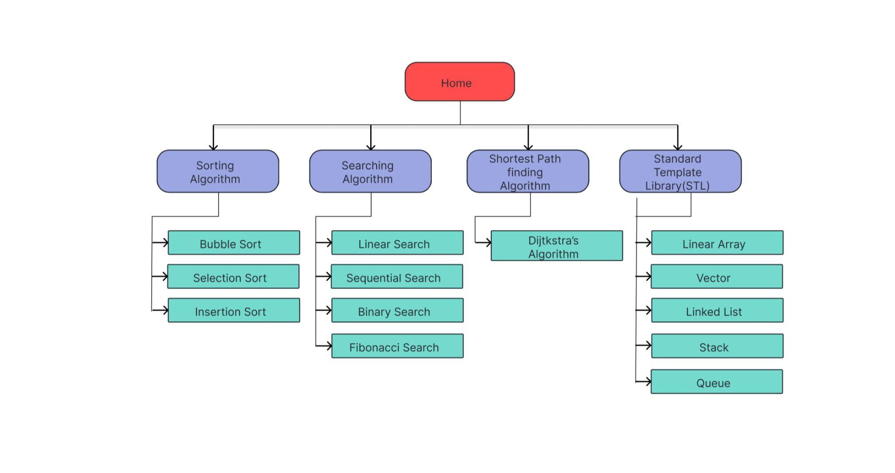

FIG 1. SYSTEM ARCHITECTURE

**4.2 FLOWCHART/ ACTIVITY DIAGRAM:**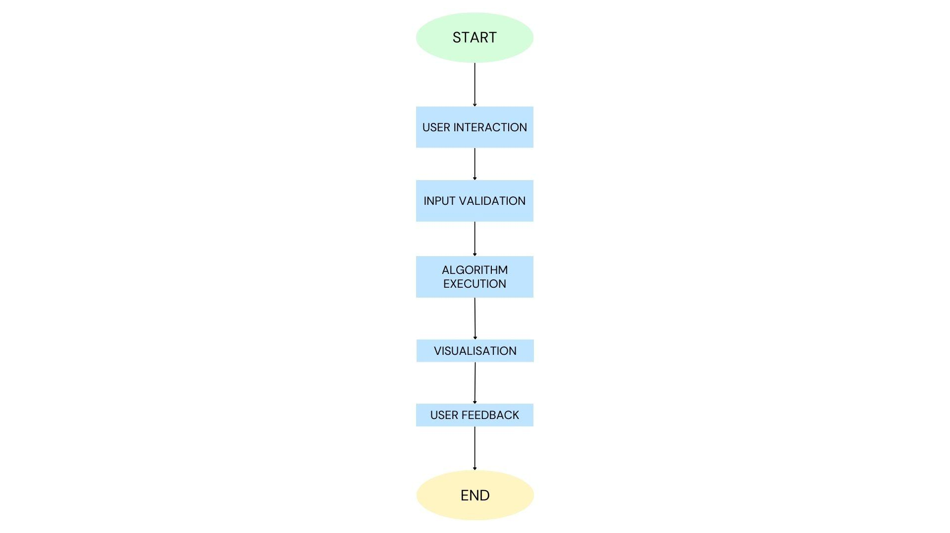

FIG 2. IMPLEMENTATION FLOWCHART

**4.3 IMPLEMENTATION CODE AND RESULTS:**

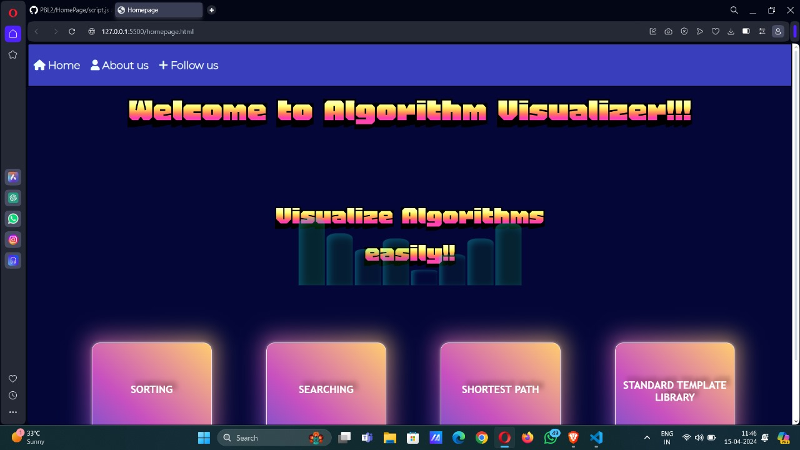

FIG 3. HOMEPAGE

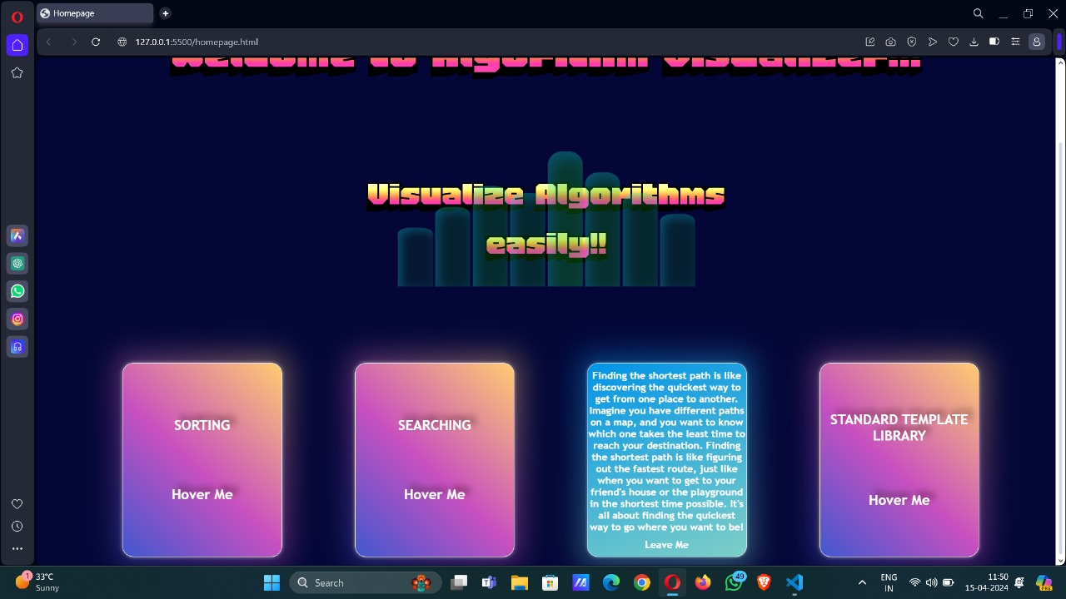

FIG 4. MENU FOR CHOICE

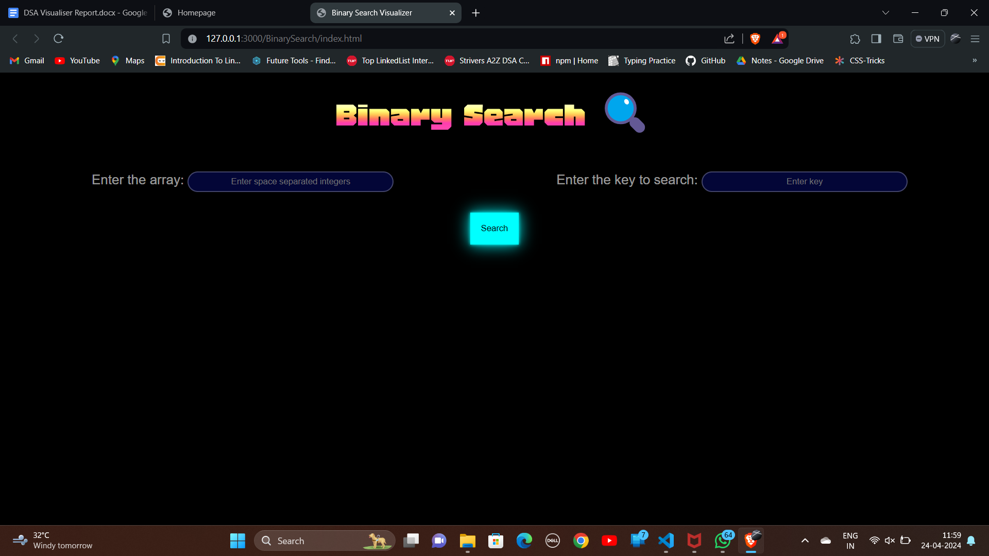

FIG 5. BINARY SEARCH INPUTS

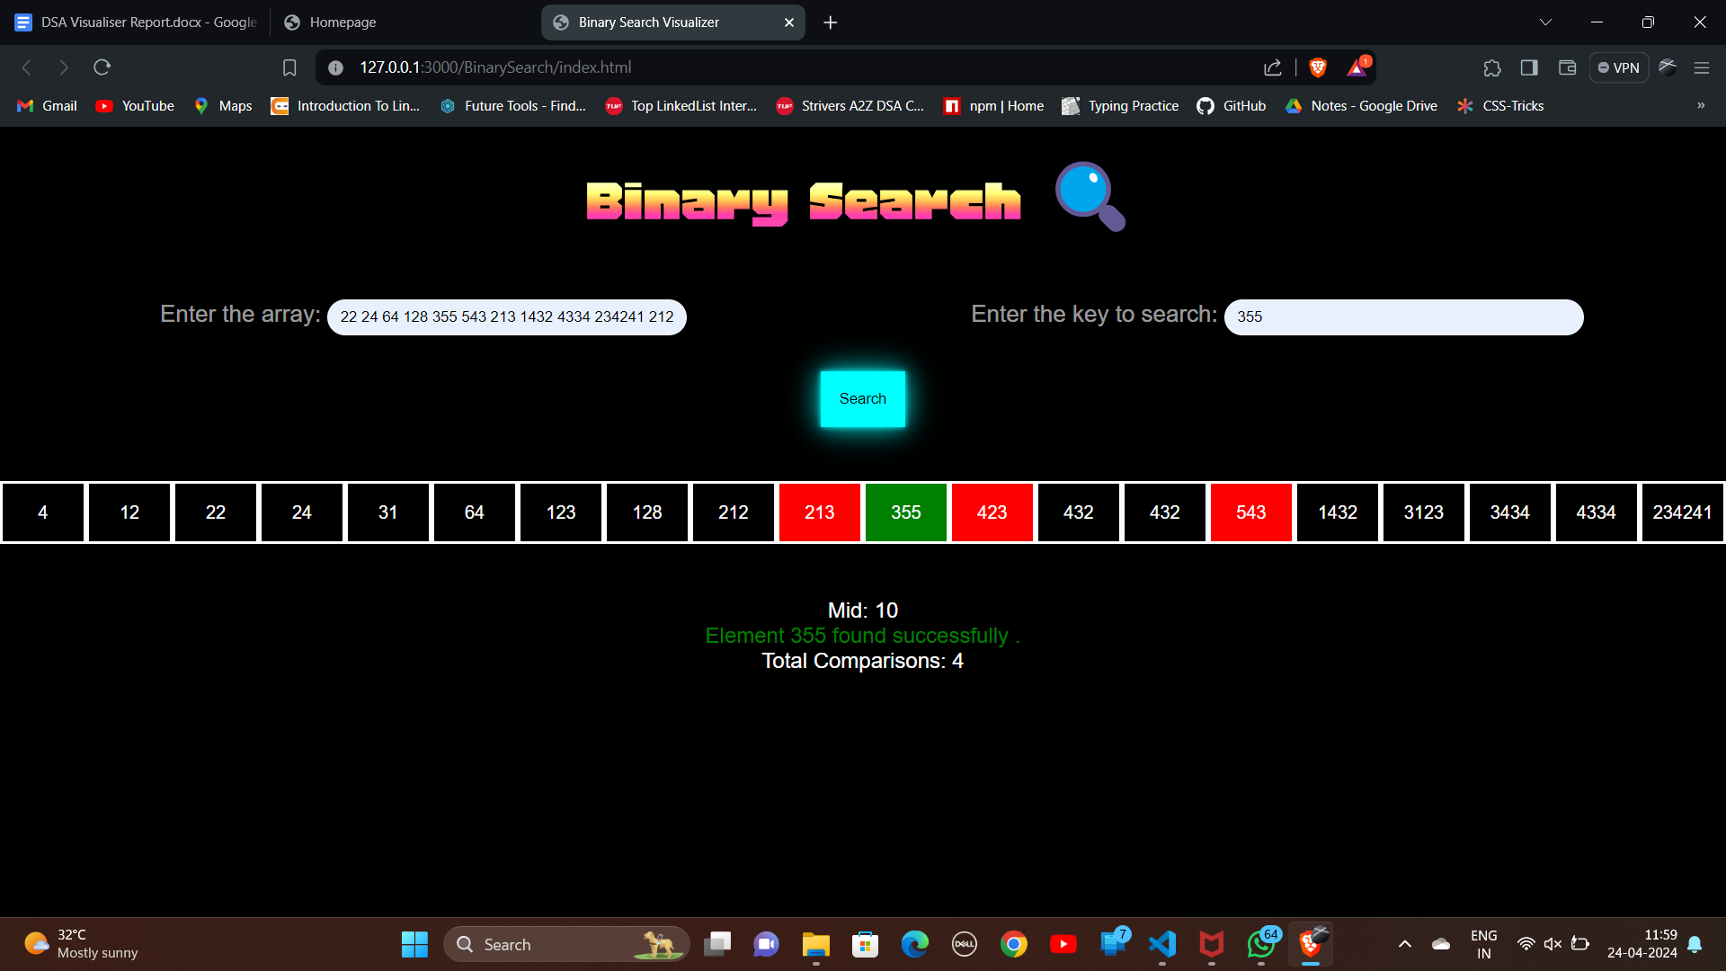

FIG 6. BINARY SEARCH RESULTS

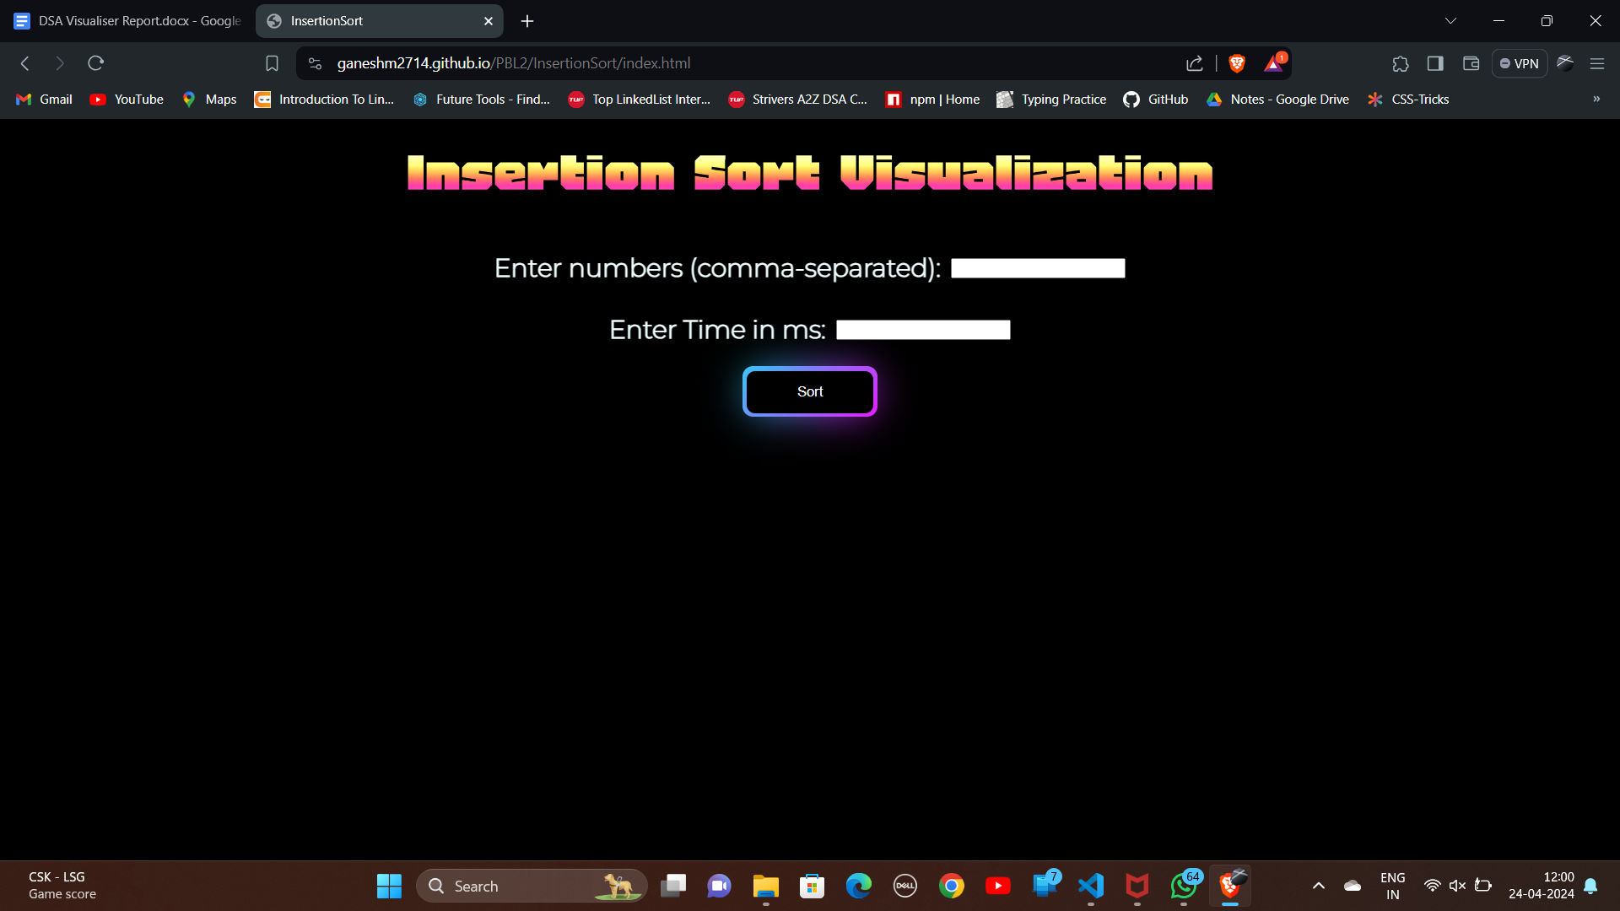

FIG 7. INSERTION SORT INPUTS

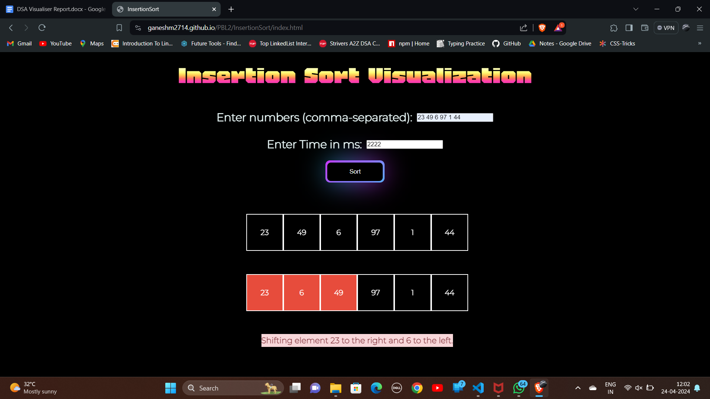

FIG 8. INSERTION SORT PROCESSING

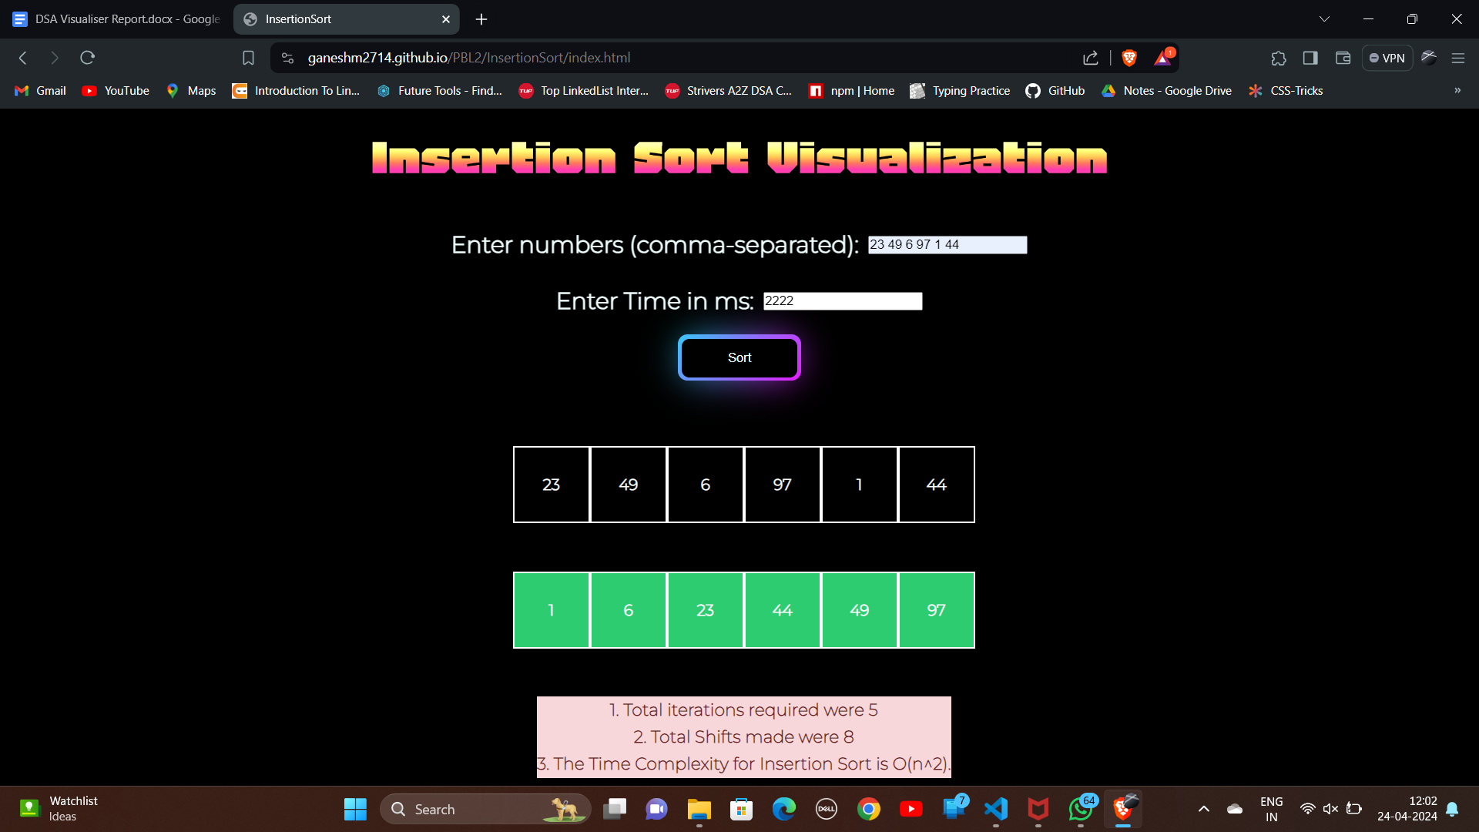

FIG 9. INSERTION SORT OUTPUT

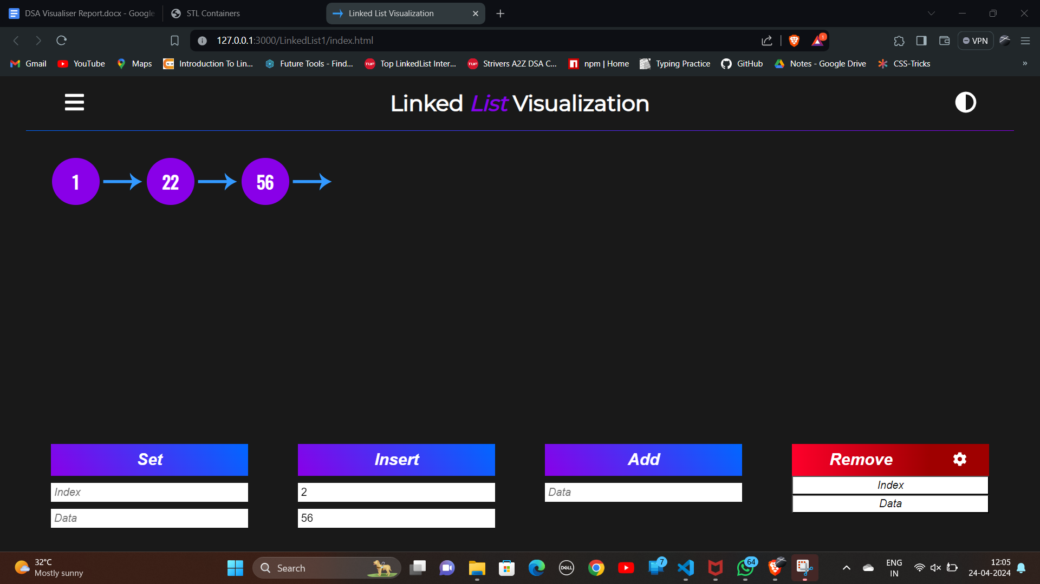

FIG 10. LINKED LIST OPERATIONS

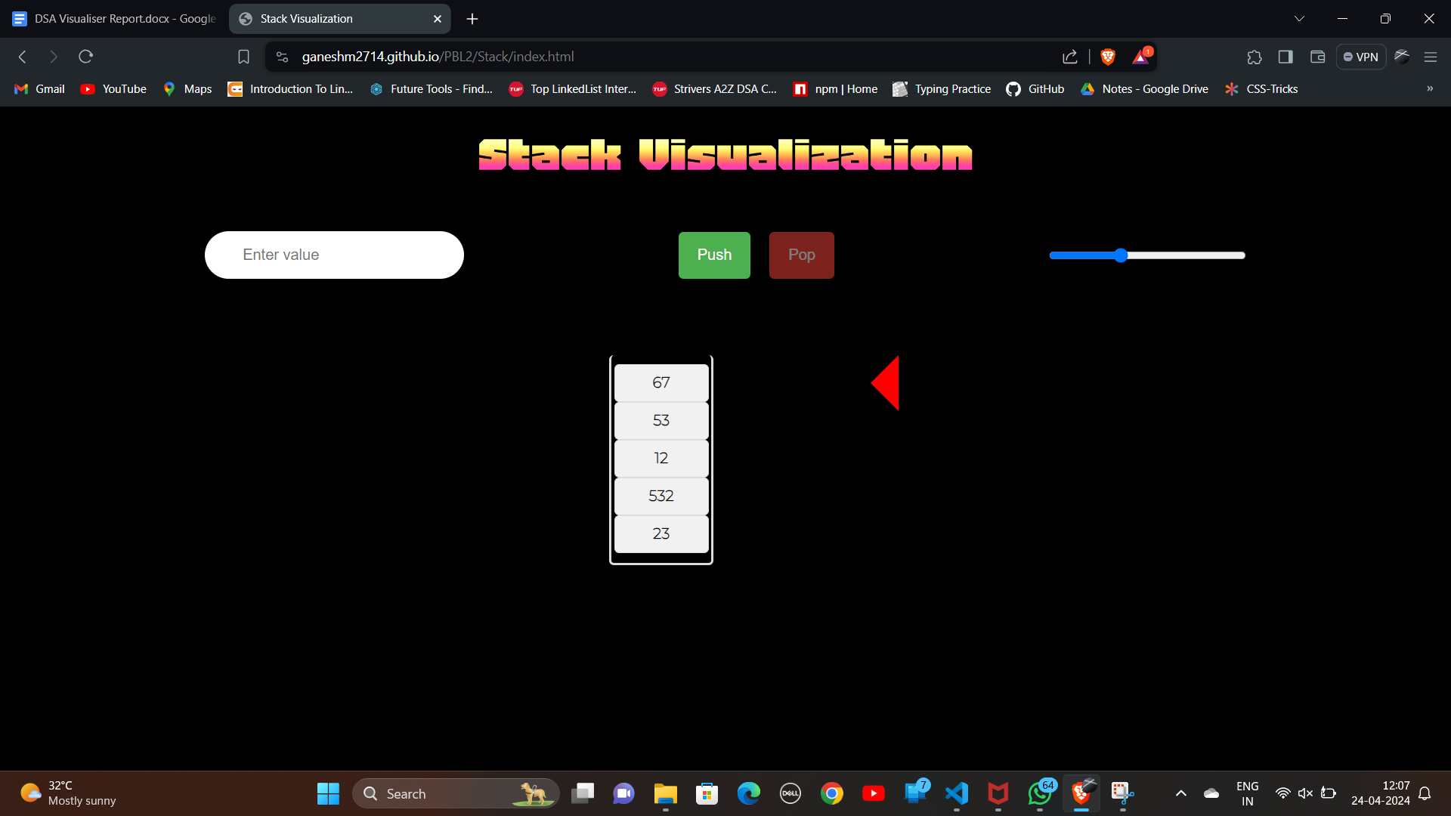

FIG 11. STACK OPERATIONS

**CODE SAMPLE**:

-BUBBLE SORT:

<!DOCTYPE html>

<html lang="en">

<head>

<meta charset="UTF-8" />

<meta name="viewport" content="width=device-width, initial-scale=1.0" />

<title>BubbleSort</title>

<link rel="stylesheet" href="style1.css" />

<link

rel="stylesheet"

href="https://cdnjs.cloudflare.com/ajax/libs/font-awesome/6.5.1/css/all.min.css"

integrity="sha512-DTOQO9RWCH3ppGqcWaEA1BIZOC6xxalwEsw9c2QQeAIftl+Vegovlnee1c9QX4TctnWMn13TZye+giMm8e2LwA=="

crossorigin="anonymous"

referrerpolicy="no-referrer"

/>

</head>

<body>

<h1 id="title">Bubble Sort Visualization</h1>

<div class="array">

<label for="arrayInput" style="margin-right: 10px"

>Enter numbers (comma-separated):

</label>

<input type="text" id="arrayInput" />

</div>

<div class="time">

<label for="time" style="margin-right: 10px">Enter Time in ms:</label>

<input type="number" id="time" />

</div>

<div id="Take">

<button onclick="visualizeBubbleSort()" class="button">Sort</button>

</div>

<br /><br />

<div class="ins">

<div class="initial-array" id="array-state-container"></div>

<div id="array-container"></div>

<div class="c"></div>

<!-- <div class="arrow"> <i class="fa-solid fa-arrow-up"></i> </div> -->

</div>

<script src="script1.js"></script>

</body>

</html>

async function sleep(ms) {

return new Promise((resolve) => setTimeout(resolve, ms));

}

async function visualizeBubbleSort() {

const arrayInput = document.getElementById("arrayInput").value;

const array = arrayInput.split(" ");

let cont = document.getElementById("array-container");

let arrayStateContainer = document.getElementById("array-state-container");

cont.innerHTML = '';

arrayStateContainer.innerHTML = '';

for (let i = 0; i < array.length; i++) {

array[i] = parseInt(array[i], 10);

}

// console.log(typeof array[0]); debugging

let iarray = [...array];

for (let i = 0; i < array.length; i++) {

let box = document.createElement("div");

box.style.display = "flex";

box.className = "array-bar";

box.style.width = "80px";

box.classList.add("array-bar");

box.style.height = `80px`;

box.innerHTML = `${array[i]}`;

box.style.color = "white";

box.style.backgroundColor = "black";

box.style.alignItems = "center";

box.style.justifyContent = "center";

box.style.border = "2px solid white";

cont.appendChild(box);

}

// arrayStateContainer.innerHTML="Initial Array: ";

for (let i = 0; i < iarray.length; i++) {

let boxi = document.createElement("div");

boxi.style.display = "flex";

boxi.className = "array-bar1";

boxi.style.width = "80px";

boxi.classList.add("array-bar1");

boxi.style.height = `80px`;

boxi.innerHTML = `${iarray[i]}`;

boxi.style.color = "white";

boxi.style.backgroundColor = "black";

boxi.style.alignItems = "center";

boxi.style.justifyContent = "center";

boxi.style.border = "2px solid white";

arrayStateContainer.appendChild(boxi);

}

// arrayStateContainer.innerHTML = "Initial Array State: " + array;

bubbleSortAnimation(array);

}

async function swapBars(bar1, bar2, value1, value2, i, j, time) {

return new Promise(resolve => {

// Swap the bars with a transition of 2 seconds

bar1.style.transition = "transform 2s";

bar2.style.transition = "transform 2s";

// Scale the bars

// bar1.style.transform = "scale(1.2)";

// bar1.style.transform = "scale(1.2)";

bar1.style.transform = "translate(80px)";

bar2.style.transform = "translate(-80px)";

// Wait for the transition to complete

setTimeout(() => {

// Swap values in the bars

bar1.innerHTML = value2;

bar2.innerHTML = value1;

// Reset the style and transition properties

bar1.style.transform = "scale(1.0)";

bar2.style.transform = "scale(1.0)";

bar1.style.transition = "none";

bar2.style.transition = "none";

document.querySelector(".c").innerHTML = ``;

resolve(); // Resolve the promise

}, time); // 2000 milliseconds = 2 seconds

});

}

//Actual Sorting:

// Add a new HTML element to display the current line of code

const codeExecutionContainer = document.querySelector(".c");

async function bubbleSortAnimation(array) {

let ite = 1;

let com = 0;

const bars = document.querySelectorAll(".array-bar");

let t1 = document.querySelector("#time").value;

for (let i = 0; i < array.length - 1; i++) {

for (let j = 0; j < array.length - 1 - i; j++) {

// Highlight bars being compared

bars[j].style.backgroundColor = "#e74c3c";

bars[j + 1].style.backgroundColor = "#e74c3c";

// Update the displayed code line

codeExecutionContainer.innerHTML = `Comparing elements at indices ${j} and ${j + 1}`;

// Wait for a short duration to visualize the comparison

await sleep(1000);

if (array[j] > array[j + 1]) {

codeExecutionContainer.innerHTML = `Swapping elements at indices ${j} and ${j + 1}`;

// Wait for a short duration to visualize the comparison

await sleep(500);

// Swap bars[j] and bars[j+1] with a promise

await swapBars(bars[j], bars[j + 1], array[j], array[j + 1], i, j, t1);

// Swap values in the array

const temp1 = array[j];

array[j] = array[j + 1];

array[j + 1] = temp1;

// Highlight the swapped bars

bars[j].style.backgroundColor = "#e78c3c";

bars[j + 1].style.backgroundColor = "#e78c3c";

// Update the displayed code line

}

else {

await sleep(1000);

bars[j].style.backgroundColor = "#e78c3c";

bars[j + 1].style.backgroundColor = "#e78c3c";

// Update the displayed code line

codeExecutionContainer.innerHTML = `No swapping needed for elements at indices ${j} and ${j + 1}`;

}

await sleep(1000);

// Reset the color and scale of the bars

bars[j].style.backgroundColor = "#3498db";

bars[j + 1].style.backgroundColor = "#3498db";

com += 1;

}

ite += 1;

}

// Highlight the sorted array

bars.forEach((bar) => (bar.style.backgroundColor = "#2ecc71"));

document.querySelector(".c").innerHTML = `1. Total iterations required were ${ite} <br>

2. Total Comparisons made were ${com} <br>

3.The Time Complexity for Bubble Sort is O(n^2). `;

}

@import url('https://fonts.googleapis.com/css2?family=Montserrat:wght@200&display=swap');

@import url("https://fonts.googleapis.com/css2?family=Protest+Strike&display=swap");

@import url("https://fonts.googleapis.com/css2?family=Honk&family=Protest+Strike&display=swap");

@import url("https://fonts.googleapis.com/css2?family=Old+Standard+TT&display=swap");

* {

margin: 0;

padding: 0;

box-sizing: border-box;

}

body {

background-color: #000000;

font-family: 'Montserrat', sans-serif;

text-align: center;

color: azure;

font-weight: 700;

line-height: 1.6;

}

#title {

font-family: 'Honk', 'Arial', sans-serif !important;

font-size: 4rem;

/* padding-top: 20px; */

background-color: #000000;

}

#Take,.array,.time{

display: flex;

align-items: center;

justify-content: center;

font-size: x-large;

margin-top: 20px;

}

.ins {

width: 98%;

margin: 20px;

display: flex;

flex-direction: column;

align-items: center;

justify-content: center;

gap: 30px;

position: absolute;

}

.initial-array {

width: 80vw;

display: inline-flex;

justify-content: center;

align-items: center;

margin-bottom: 20px;

}

#array-container {

display: inline-flex;

justify-content: center;

margin-bottom: 20px;

align-items: center;

width: 80vw;

}

.code {

color: white;

/* width: 100vw; */

max-width: 800px;

margin: 0 auto;

padding: 20px;

/* background-color: rgba(0, 0, 0, 0.8); */

border-radius: 10px;

font-size: 1.1rem;

font-family: 'Segoe UI', Tahoma, Geneva, Verdana, sans-serif;

overflow-x: auto;

}

.arrow {

position: relative;

display: none;

}

/* BUTTON Design */

.button {

position: relative;

width: 120px;

height: 40px;

background-color: #000;

display: flex;

align-items: center;

color: white;

flex-direction: column;

justify-content: center;

border: none;

padding: 12px;

gap: 12px;

border-radius: 8px;

cursor: pointer;

}

.button::before {

content: '';

position: absolute;

inset: 0;

left: -4px;

top: -1px;

margin: auto;

width: 128px;

height: 48px;

border-radius: 10px;

background: linear-gradient(-45deg, #e81cff 0%, #40c9ff 100% );

z-index: -10;

pointer-events: none;

transition: all 0.6s cubic-bezier(0.175, 0.885, 0.32, 1.275);

}

.button::after {

content: "";

z-index: -1;

position: absolute;

inset: 0;

background: linear-gradient(-45deg, #fc00ff 0%, #00dbde 100% );

transform: translate3d(0, 0, 0) scale(0.95);

filter: blur(20px);

}

.button:hover::after {

filter: blur(30px);

}

.button:hover::before {

transform: rotate(-180deg);

}

.button:active::before {

scale: 0.7;

}

.c {

background-color: #f8d7da; /* Highlight color */

color: #721c24; /* Text color */

font-size: 1.1rem;

font-weight: bold; /* Bold text for better visibility */

}

**Chapter 5**

**OTHER SPECIFICATIONS**

**5.1 ADVANTAGES:**

1. Enhanced Learning Experience:
   1. The DSA Visualiser revolutionises the learning experience by transforming abstract algorithmic concepts into tangible visual representations. Through dynamic animations and interactive simulations, users can witness the inner workings of sorting, searching, Dijkstra's, and STL algorithms in action.
   2. Complex algorithms become more digestible and understandable as users observe each step of the algorithm's execution in real-time. This visual approach bridges the gap between theoretical knowledge and practical application, making it easier for beginners to grasp fundamental concepts.
2. Comprehensive Coverage:
   1. Unlike traditional learning resources that may focus on isolated aspects of algorithms, the DSA Visualiser provides a holistic understanding by covering a wide array of essential topics. Sorting, searching, Dijkstra's, and STL algorithms represent foundational pillars in computer science and data structures, ensuring users develop a robust understanding of core concepts.
   2. By consolidating these topics into a single platform, users benefit from a cohesive learning experience where they can explore interrelationships between different algorithms and understand their respective strengths and weaknesses.
3. Real-time Visualisation:
   1. One of the standout features of the DSA Visualiser is its ability to provide real-time visualisation of algorithmic processes. As users input data and select algorithms, they witness the algorithm's execution step-by-step, observing how data elements are manipulated and rearranged at each iteration.
   2. This dynamic visualisation not only enhances comprehension but also promotes engagement and retention. Users gain insights into algorithm behaviour, learning how algorithms respond to different inputs and scenarios in a hands-on manner.
4. Customization and Control:
   1. The DSA Visualiser empowers users with customization options and control over their learning experience. Users can adjust algorithm parameters, input data sets, and visualisation settings to tailor the experience to their preferences and learning objectives.
   2. This level of control encourages exploration and experimentation, allowing users to test hypotheses, compare algorithmic performance, and gain deeper insights into algorithm behaviour. By putting users in the driver's seat, the visualiser promotes active learning and problem-solving skills.
5. Scalability and Accessibility:
   1. As a web-based platform, the DSA Visualiser offers unparalleled scalability and accessibility. Users can access the platform from any internet-enabled device, including desktops, laptops, tablets, and smartphones, without the need for additional software installation.
   2. This accessibility ensures that the visualiser reaches a broad audience of learners, including students, educators, and enthusiasts, regardless of their geographical location or device preferences. Furthermore, the platform's scalability enables it to accommodate growing user demand and expand its reach over time.
6. Continuous Improvement:
7. The DSA Visualiser is committed to continuous improvement and evolution. Through agile development methodologies and responsive feedback mechanisms, the platform remains dynamic and adaptive, evolving in response to user needs, technological advancements, and educational trends.
8. Regular updates and enhancements ensure that the visualiser stays relevant and effective, incorporating new features, algorithms, and educational resources to enrich the learning experience. By staying at the forefront of innovation, the visualiser maintains its position as a leading educational tool in the field of computer science and algorithm education.

**5.2 LIMITATIONS:**

1. Scope Limitations:

While the DSA Visualiser covers a wide range of sorting, searching, Dijkstra's, and STL algorithms, it may not include every algorithm or cover advanced topics. Users seeking in-depth exploration of specialised algorithms or advanced algorithmic techniques may find the visualiser's scope limited.

1. Complexity of Algorithms:

Some algorithms, particularly those with intricate logic or complex data structures, may be challenging to visualise effectively. As a result, users may encounter difficulty in understanding or interpreting the visual representations, especially for algorithms with high computational complexity or non-linear behaviour.

1. Simplification of Concepts:

To facilitate beginner-level learning, the DSA Visualiser may simplify certain algorithmic concepts or abstract away technical details. While this approach enhances accessibility for novice users, it may overlook nuances or intricacies present in real-world implementations, potentially leading to misconceptions or incomplete understanding.

1. Performance Considerations:

Real-time visualisation of algorithms, especially for large data sets or computationally intensive operations, may impose performance limitations. Users may experience delays or sluggishness in visualisation rendering, particularly when executing algorithms with high time complexity or memory usage.

1. Browser Compatibility and Device Support:

The effectiveness of the DSA Visualiser may vary depending on users' web browsers, device specifications, and internet connectivity. Compatibility issues or performance disparities across different browsers or devices could impact the user experience, particularly for users with older hardware or less reliable internet connections.

1. Educational Effectiveness:

While the DSA Visualiser aims to enhance learning outcomes, its educational effectiveness may depend on various factors, including user engagement, prior knowledge, and instructional support. Users may require supplementary resources or guidance to fully grasp algorithmic concepts beyond what the visualiser provides.

**5.3 APPLICATIONS:**

1. Computer Science Education: The DSA Visualiser can be used as a valuable educational tool in computer science courses at schools, colleges, and universities. It provides students with a hands-on learning experience, helping them understand complex algorithms through interactive visualisation.
2. Self-Study and Skill Enhancement: Individuals interested in learning algorithms and data structures can use the DSA Visualiser for self-study purposes. It offers a structured and engaging way to explore sorting, searching, Dijkstra's, and STL algorithms, allowing learners to enhance their programming skills at their own pace.
3. Technical Interview Preparation: Job seekers preparing for technical interviews in software engineering or related fields can benefit from the DSA Visualiser. It allows them to practise implementing and understanding common algorithms, thereby improving their problem-solving skills and performance during interviews.
4. Programming Competitions and Hackathons: Participants in programming competitions and hackathons can utilise the DSA Visualiser to brainstorm and prototype algorithmic solutions to given problems. It serves as a tool for visualising and testing algorithm implementations in a collaborative and competitive environment.
5. Educational Workshops and Bootcamps: Educational workshops and bootcamps focused on algorithmic concepts can incorporate the DSA Visualiser into their curriculum. It provides instructors with a dynamic teaching aid to engage students and reinforce theoretical concepts with practical demonstrations.
6. Open Source Contribution and Research: Researchers and developers in the field of computer science can contribute to the DSA Visualiser project by extending its functionality or exploring innovative visualisation techniques. It serves as a platform for experimentation and collaboration within the open-source community.
7. Algorithm Analysis and Experimentation: Professionals and academics involved in algorithm analysis and experimentation can use the DSA Visualiser to visualise the performance of different algorithms under varying conditions. It facilitates comparative analysis and helps researchers draw insights into algorithmic behaviour and efficiency.
8. Educational Outreach Programs: Organizations and institutions conducting educational outreach programs in STEM subjects can utilise the DSA Visualiser to introduce students to algorithmic thinking and problem-solving. It offers an interactive and accessible platform for inspiring interest in computer science among diverse audiences.
9. Software Development Training: Companies providing software development training to their employees can incorporate the DSA Visualiser into their training programs. It offers a practical and engaging way for developers to enhance their understanding of algorithms and data structures relevant to their work.
10. Curriculum Enhancement in Developing Countries: In developing countries where access to quality educational resources may be limited, the DSA Visualiser can serve as a valuable tool for enhancing computer science curricula in schools and universities. It provides students with access to interactive learning experiences that complement traditional teaching methods.

**Chapter 6**

**CONCLUSION & FUTURE WORK**

In conclusion, the DSA Visualiser project represents a significant advancement in the field of algorithm education and visualisation. By providing an intuitive and interactive platform for exploring sorting, searching, Dijkstra's, and STL algorithms, the visualiser offers users a unique opportunity to deepen their understanding of fundamental concepts in computer science and data structures.

Throughout this project, we have witnessed the power of visualisation in making abstract algorithmic concepts more tangible and accessible, particularly for beginner-level learners. The real-time execution and dynamic animations provided by the visualiser have facilitated a more engaging and immersive learning experience, enabling users to observe algorithmic processes in action and gain insights into their behaviour and performance.

While the DSA Visualiser project has achieved significant milestones, it is essential to acknowledge its limitations and areas for future improvement. Challenges such as algorithm complexity, performance considerations, and educational effectiveness underscore the need for ongoing refinement and enhancement of the visualiser platform. Additionally, ensuring accessibility, privacy, and sustainability are critical considerations in the continued development and deployment of the visualiser.

Looking ahead, the DSA Visualiser project has the potential to make a lasting impact on algorithm education and learning outcomes across diverse audiences. By embracing innovation, collaboration, and feedback-driven iteration, we can further elevate the visualiser's effectiveness as a tool for empowering learners, fostering computational thinking skills, and inspiring curiosity in the world of algorithms.

In conclusion, the DSA Visualiser project stands as a testament to the transformative power of technology in enhancing educational experiences and equipping learners with the knowledge and skills needed to thrive in an increasingly digital world. As we continue to refine and expand the visualiser's capabilities, we remain committed to its mission of democratising access to algorithm education and empowering learners of all backgrounds to unlock their potential in computer science and beyond.

**Chapter 7**

**REFERENCES**

[1] Goodrich, M. T., Tamassia, R., & Goldwasser, M. H. (2014). Data Structures

and Algorithms in Java (6th ed.). Wiley.

[2] Visualisation references:

Morin, P., & Muller, D. (2010). Visualizing Data Structures and Algorithms through Animation. ACM Transactions on Computing Education (TOCE), 10(4), 1-29.

Almasi, G. S., & Gottlieb, A. (1989). Highly parallel computing. ACM Computing Surveys (CSUR), 21(1), 1-63.

[3] Online resources:

GeeksforGeeks (<https://www.geeksforgeeks.org/>)

Khan Academy (<https://www.khanacademy.org/computing/computer-science/algorithms>)

Stack Overflow (<https://stackoverflow.com/>)